./



Version Number:

Team Members :

Team No:

Module: Model Based System Engineering

|  |  |  |  |  |  |
| --- | --- | --- | --- | --- | --- |
| **Ver.Rel. No.** | **Release Date** | **Prepared. By** | **Reviewed By** | **Approved By** | **Remarks/Revision Details** |
| 1 | 20-2-2022 | Vaishnavi P |  |  |  |
|  |  |  |  |  |  |
|  |  |  |  |  |  |
|  |  |  |  |  |  |
|  |  |  |  |  |  |

**Document History**

# 

Case Study-Smart Watch

Description-Wearable devices like Smart Watches Can perform Multiple functions like

Fitness tracking, Steps counting and can perform most of the functions that a mobile

Phone can do.

High Level Requirements

-To provide an interface to the user to interact and display time and provide apps

-To provide Bluetooth Connectivity to connect it to mobile phone

-To make the watch portable by providing with battery and charger

-To Sense Temperature and Pressure

Low Level Requirements

-An Interface is provided to the user by capacitive touch screen and android operating

System.

-Bluetooth Connectivity is provided to the user by inbuilt module in SOC

-A suitable battery to power the watch and size of battery is taken care.

-Temperature, Pressure etc are sensed by those particular sensors and a module to

Convert anlog to digital values is installed in system on chip .digital to analog is

Built in system on chip for drivers such as LED and Vibration motors.

Block Diagram

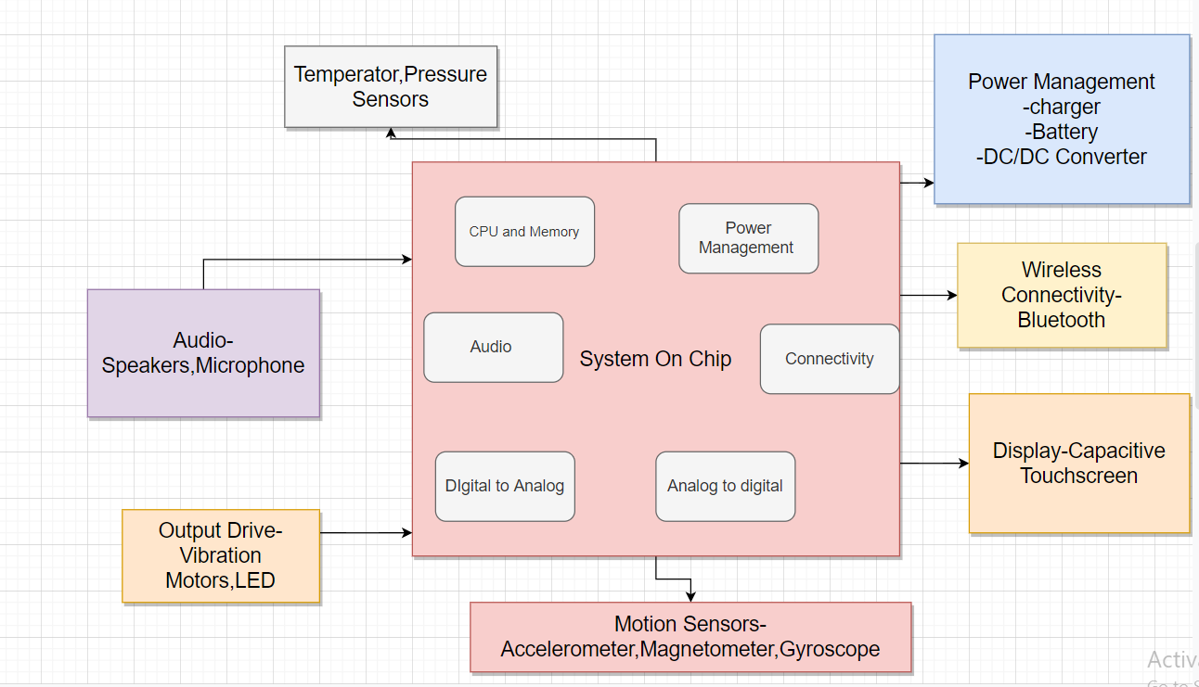

Component Description

*System on chip-All the necessary functions required for the application is integrated

On a single chip. Modern controllers such as the PSoC integrate sophisticated analog

and programmable digital functionality in a single chip, along with an ARM cortex-M

core, utilizing the power of the ARM architecture.

*Power Management circuit is implemented

*Sensors-Motion Sensors-Accelerometer,Magnetometer,Gyroscope ,Temperature

and pressure sensors are used

*Motors and LEDs are used as ouput drives.